**Title** : **AI-powered Nutrition Analyzer for Fitness Enthusiasts**

**Team Size :** 5

**Team Leader :**SOORAJ K

**Team member :** RAM BALAJI

**Team member :**PRASSANA KUMAR

**Team member :** PRAVEEN RAJ S

**Team member :** RITHVIK THOTA

**Contents Discussed :**

**1.1 Access the resources (courses) in the project dashboard:** We are able to access all resources and courses which are required for the project Development from the website menu and our project has successfully approved by our college spoc.

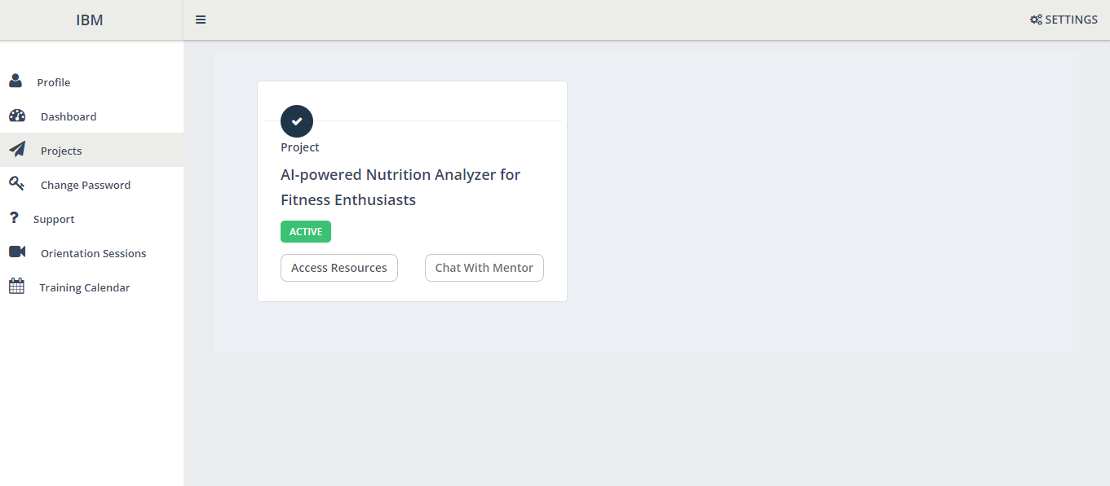

**1.2 Join the mentoring channel via platform & rocket-chat mobile app:** We have Downloaded Rocket-chat application and joined the respective project channel using the credentials.

**1.3 Access the guided project workspace:** The Pre-requisites,Project templates which are necessary for our project are installed.

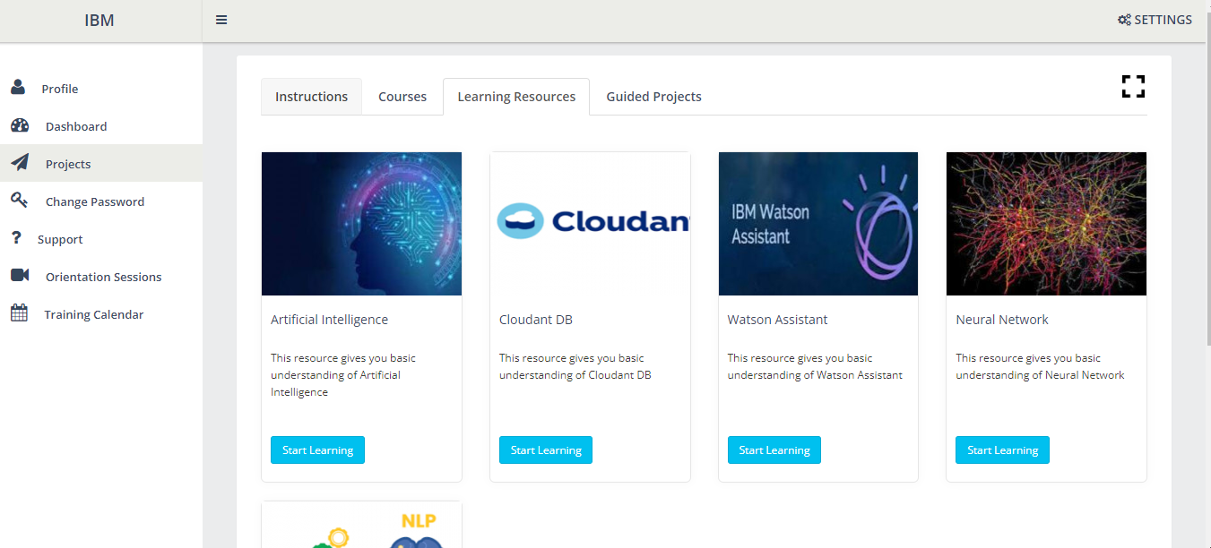

**1.4 Register on IBM Academic Initiative & Apply Feature code for IBM Cloud Credits:**We have Attended the sessions on IBM SkillsBuild, Registered on IBM SkillsBuild, applied feature code to receive credits for IBM Cloud, Started completing the skill badges.

**1.5 Create GitHub account & collaborate with Project Repository in project workspace:**Our Team Leader has Collaborated with git account by using activation mail and added remaining team members.

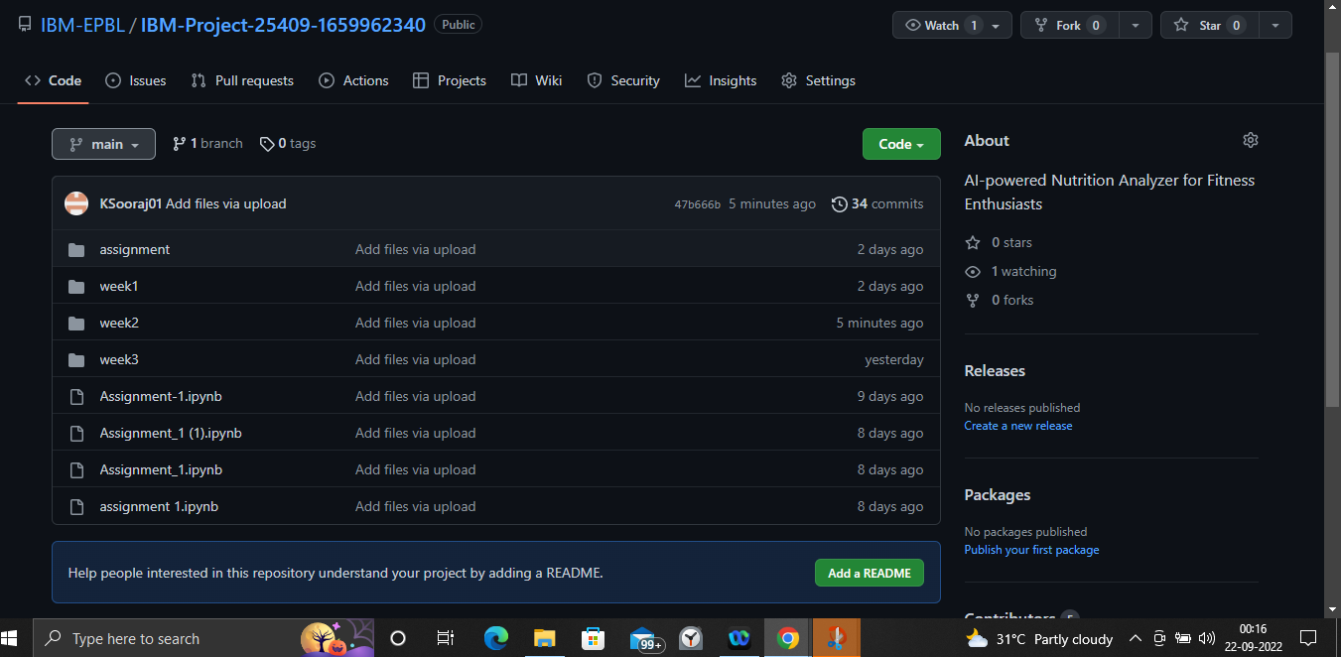

**1.6 Set-up the Laptop / Computers based on the prerequisites for each technology track :** Installed Anaconda Prompt, jupyter notebook IDE, spyder IDE required for developing our project.

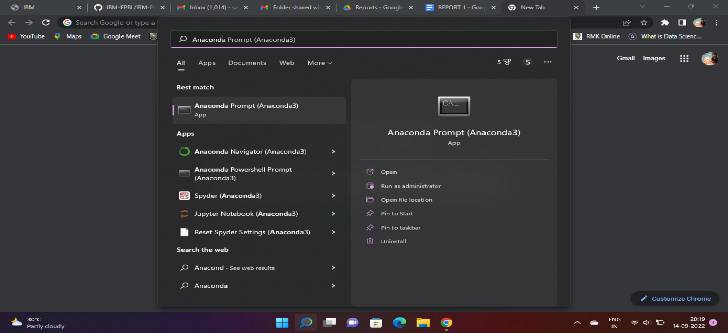

**Conclusion:**

Our Project - Developing an AI-powered Nutrition Analyzer for Fitness Enthusiast had been successfully approved by our college spoc. We have installed all the prerequisites for the project development and also collaborated successfully using a Git account.